Tic_Tac_Toe App Documentation

This project made by member of group 604.23E :Karimli Samira,Recebova Zulfiyya,Huseynli Nazrin.

This was our github link where you can view the code from here-<https://github.com/zulfiyyrecebovaa/tiktaktoe>

NOTE: Samira’s code in another branch

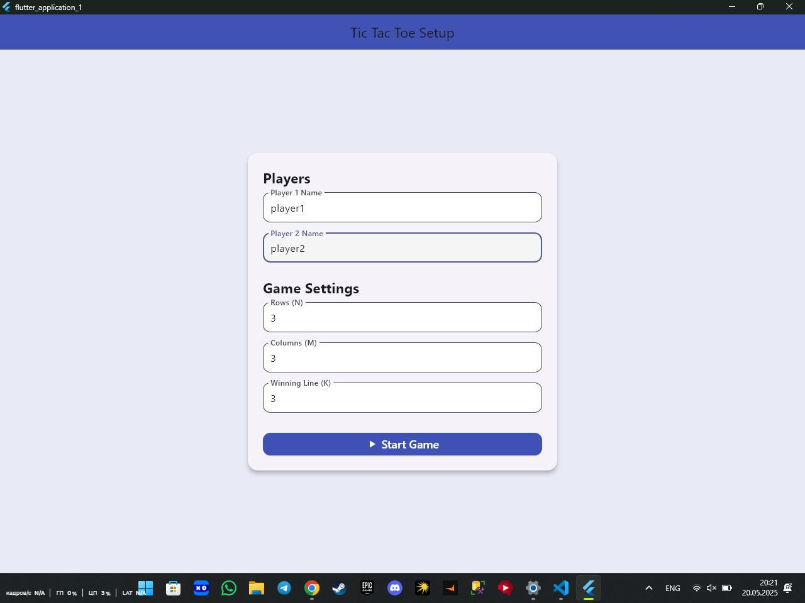First,me l mean Samira create structure,main and setup page

Then,Zulfiyya take code github repositories which is a Samira created and created game page,also adding some page.

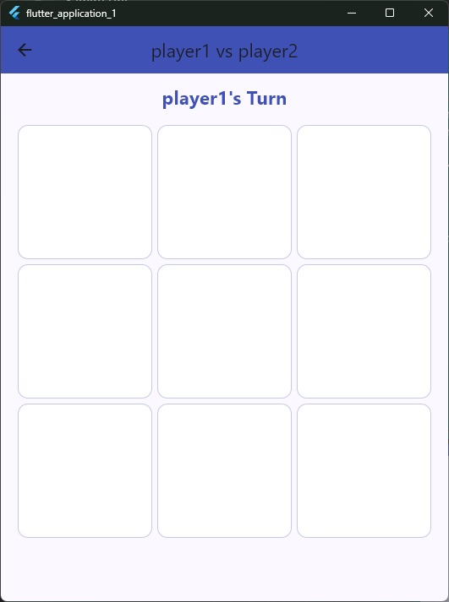

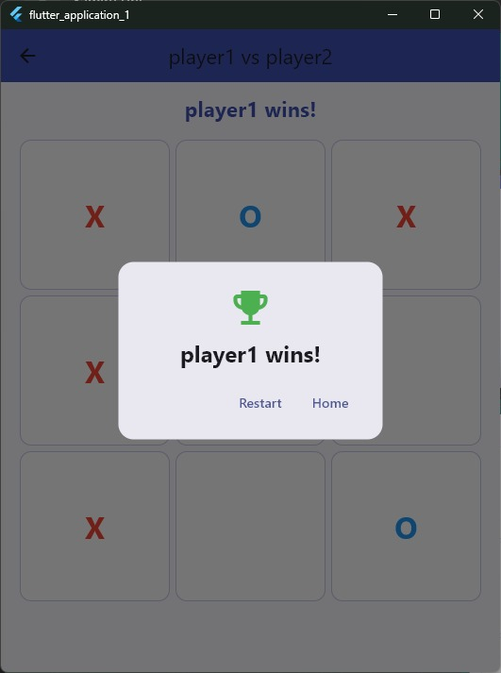

The end Nazrin take code which is a Samira and Zulfiyya created and change design .

When we add players name and determine row,column and winning size ,click start game button we can start playing.ln the end, we see who won on the screen,and if we want to play again,we press the “restart” button.